Screenshots

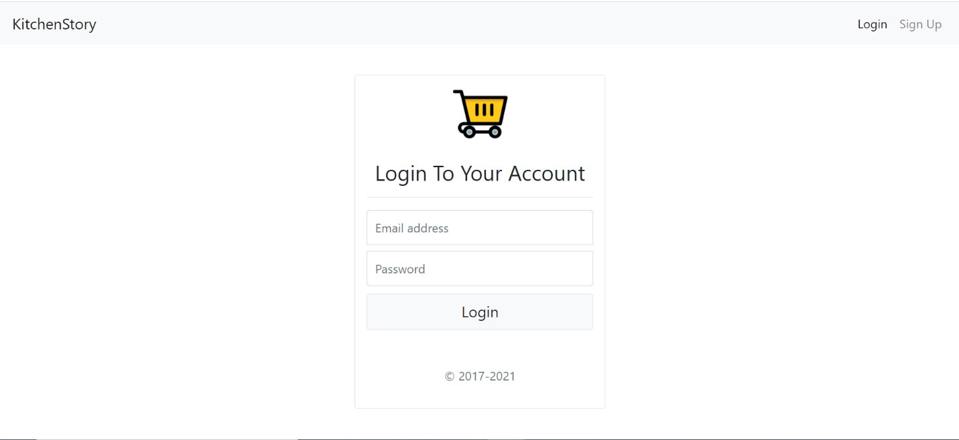1. Login Page

2. Signup Page

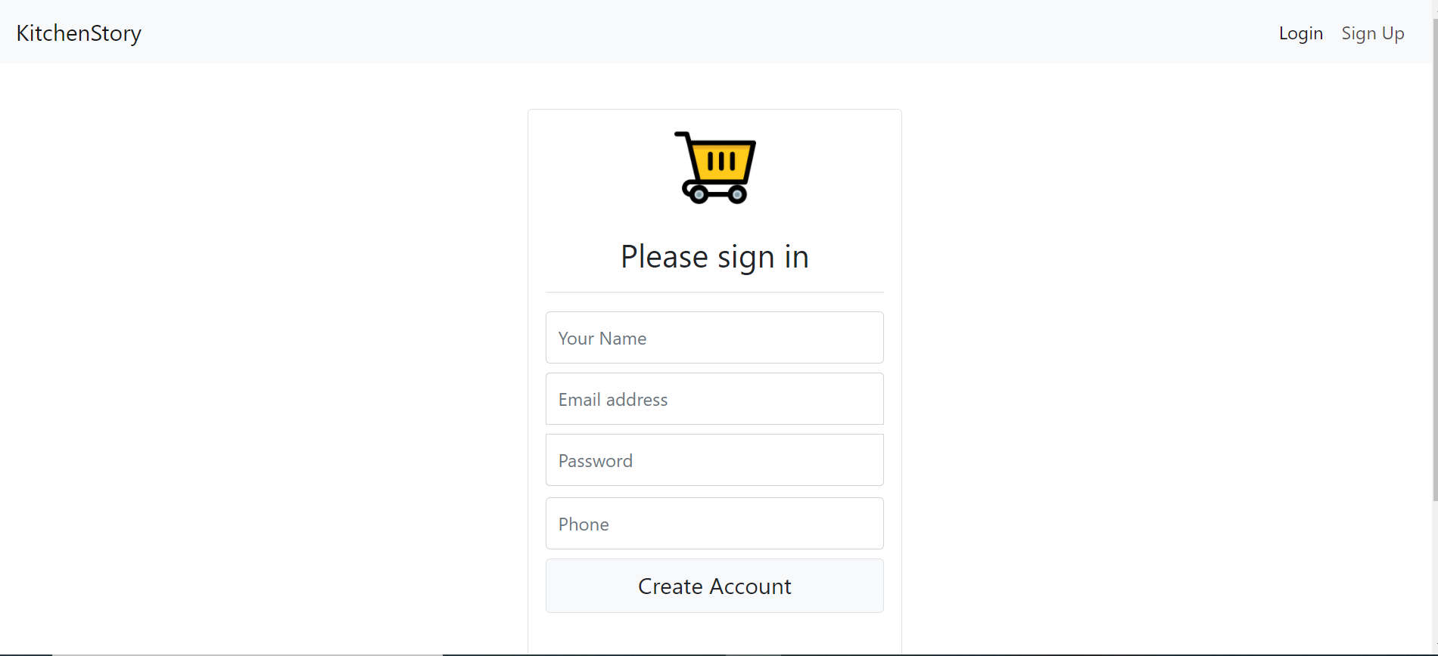

3. Store Page and Store Items

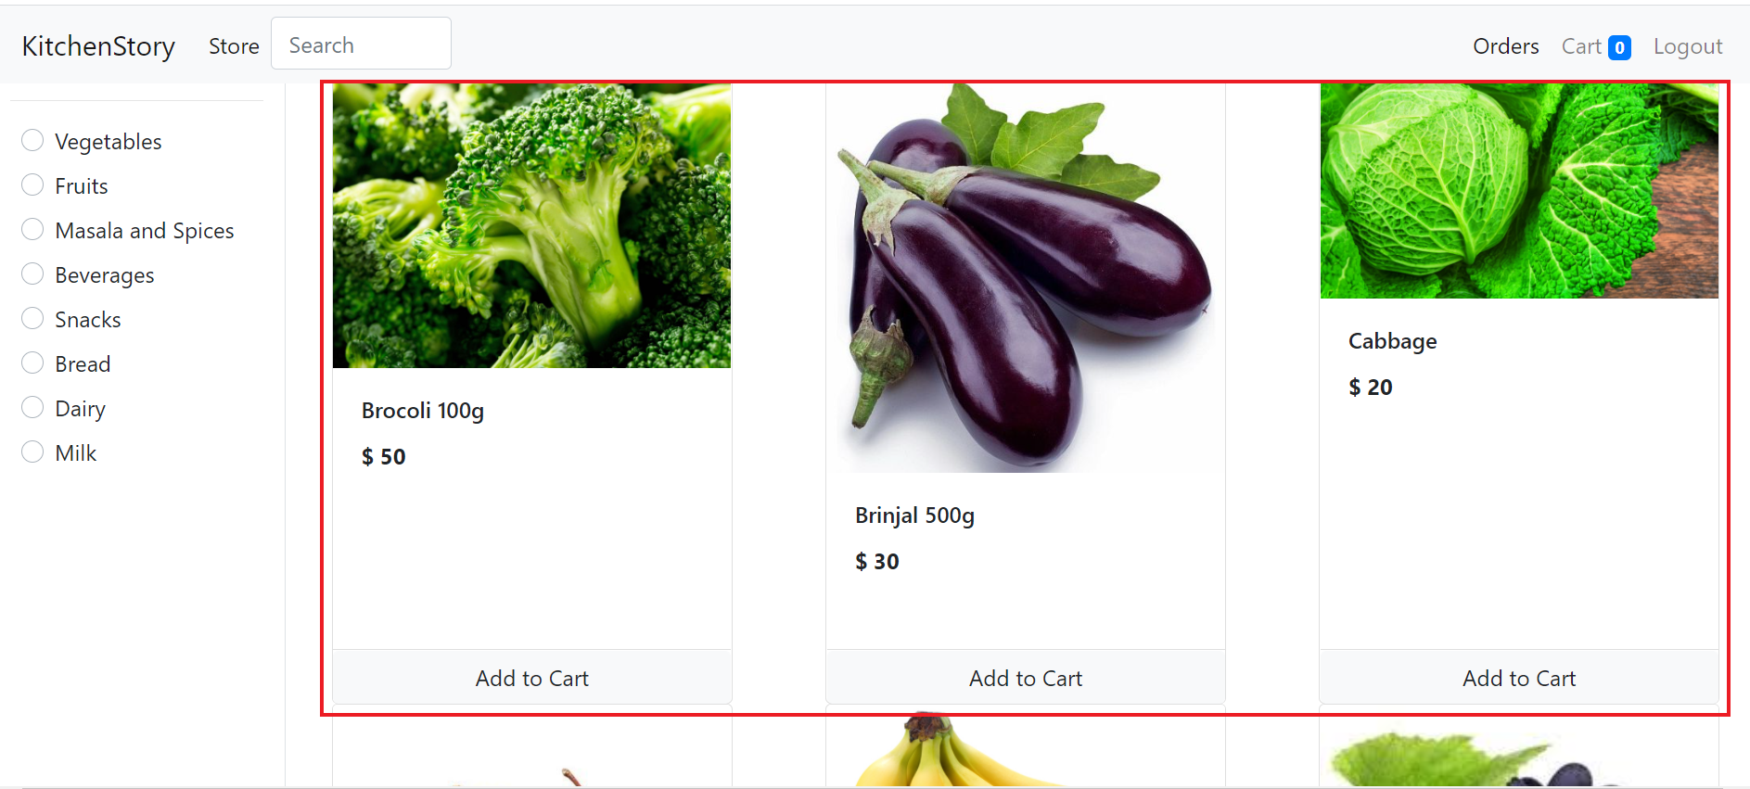

4. Filter Based on Category

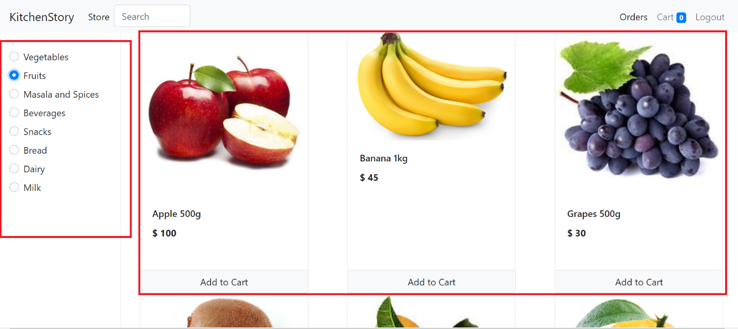

5. Orders, Cart and Logout Feature

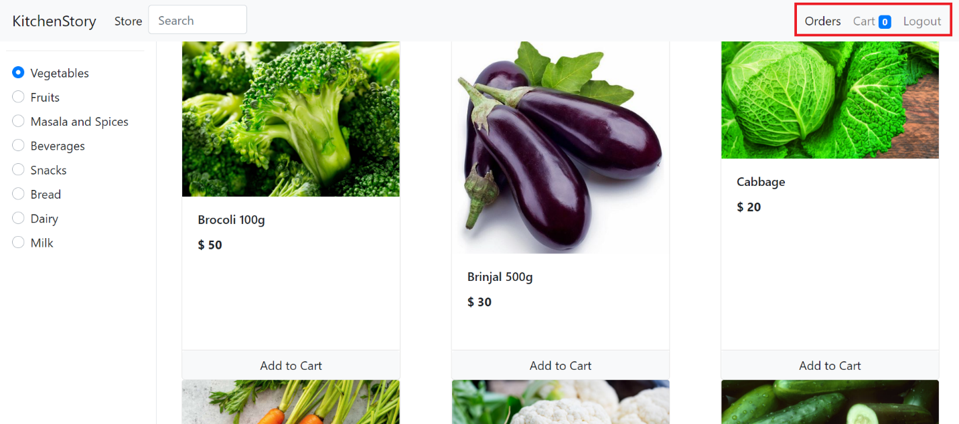

6. Search Function

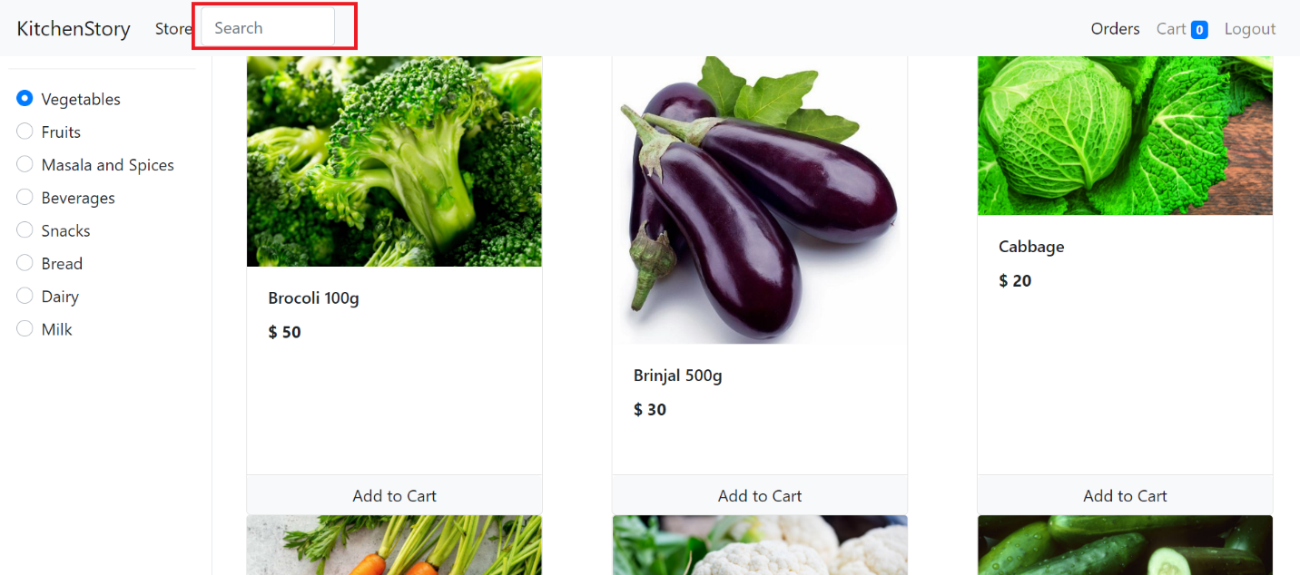

7. Add to Cart Function

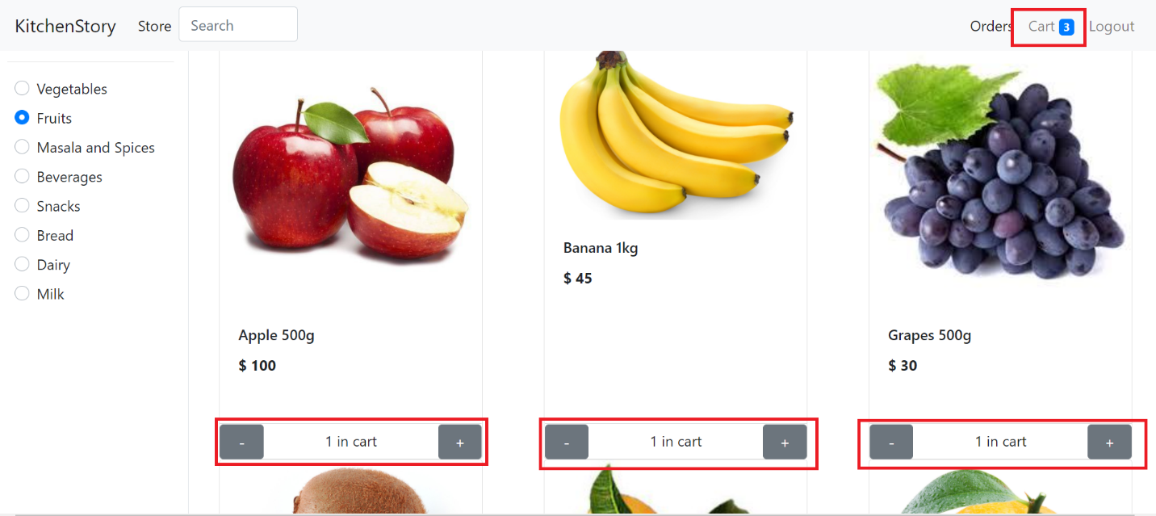

8. When cart is clicked it takes to Cart page

The cart has features to add the quantity and total

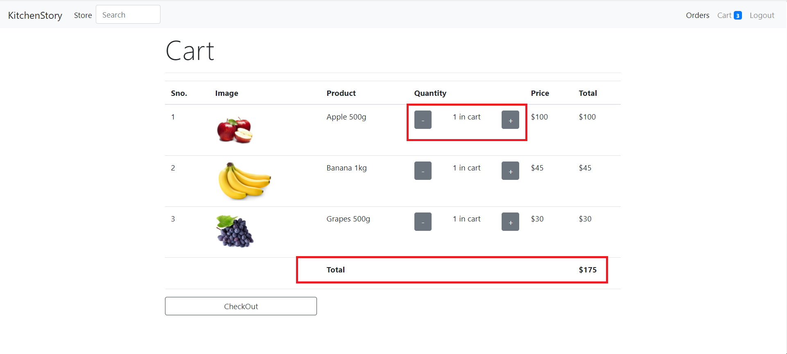

9. When quantity increases total changes

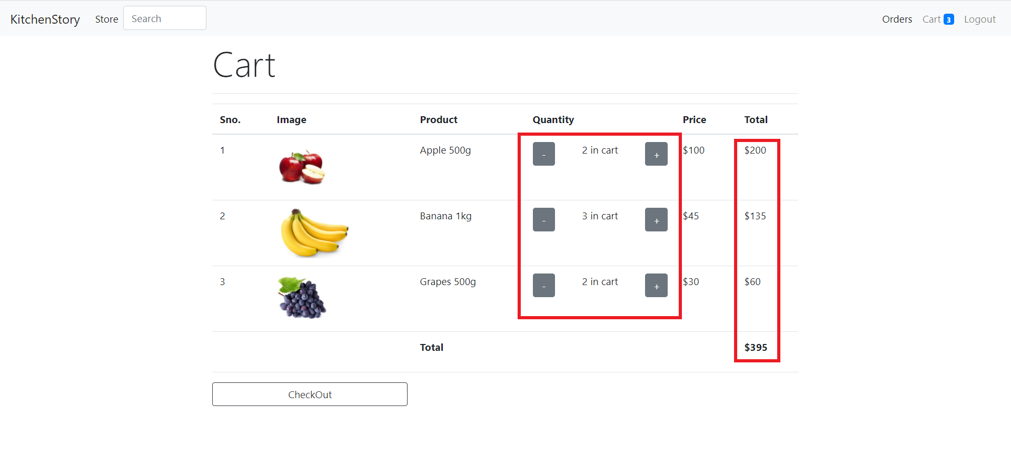

10. After selecting everything checkout button is clicked

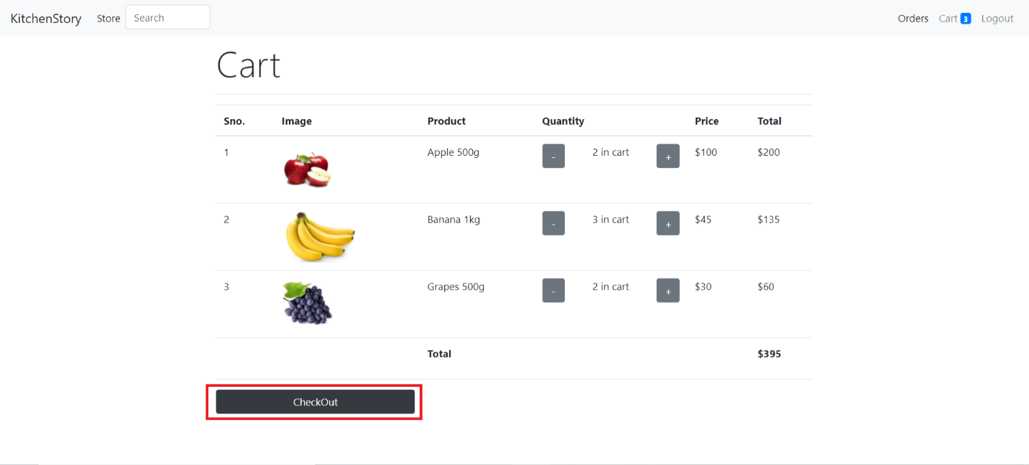

11. When checkout button is clicked the Checkout form appears which have details of cart items, billing address details, payment method

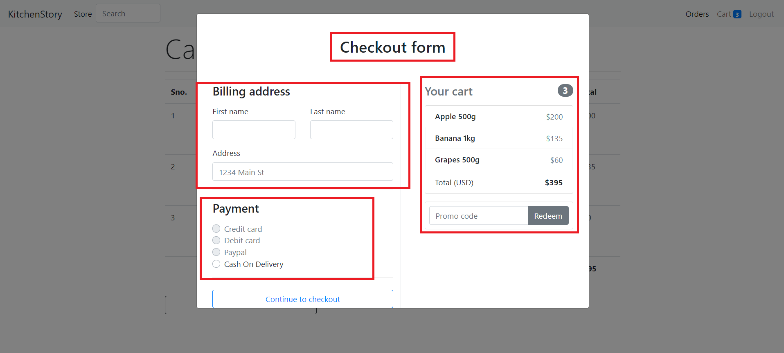

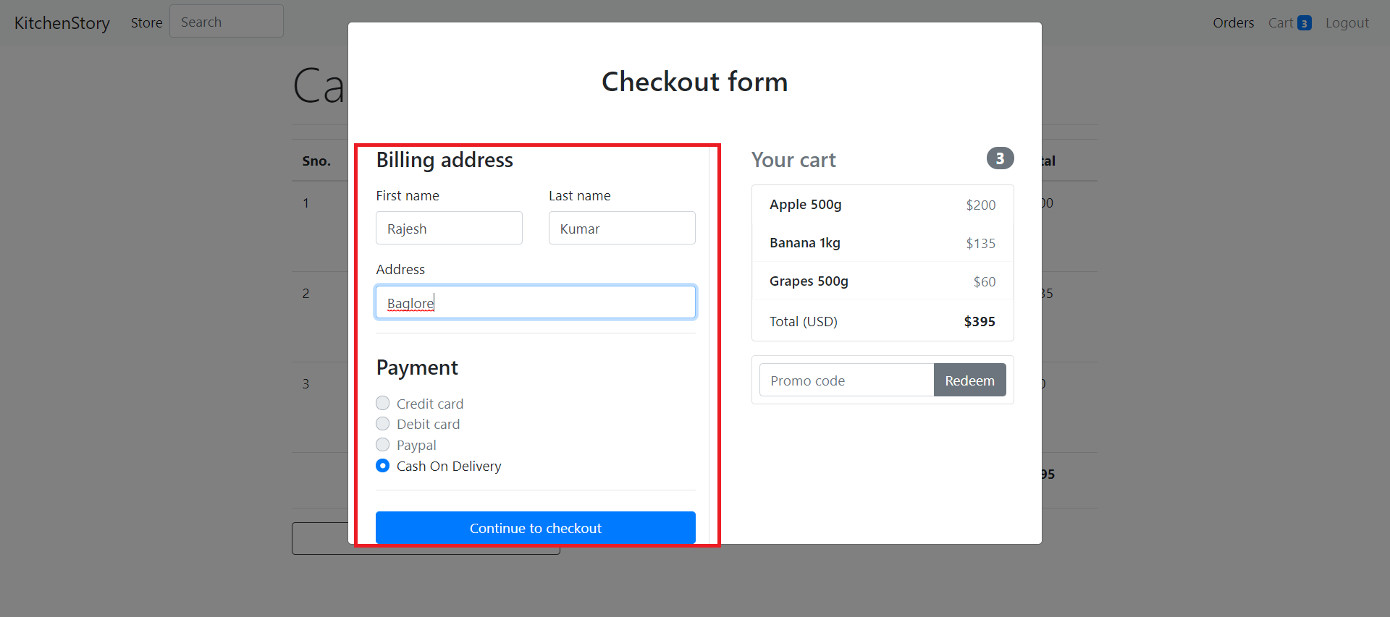

12. When continue to checkout is clicked thank you page appears and cart becomes empty

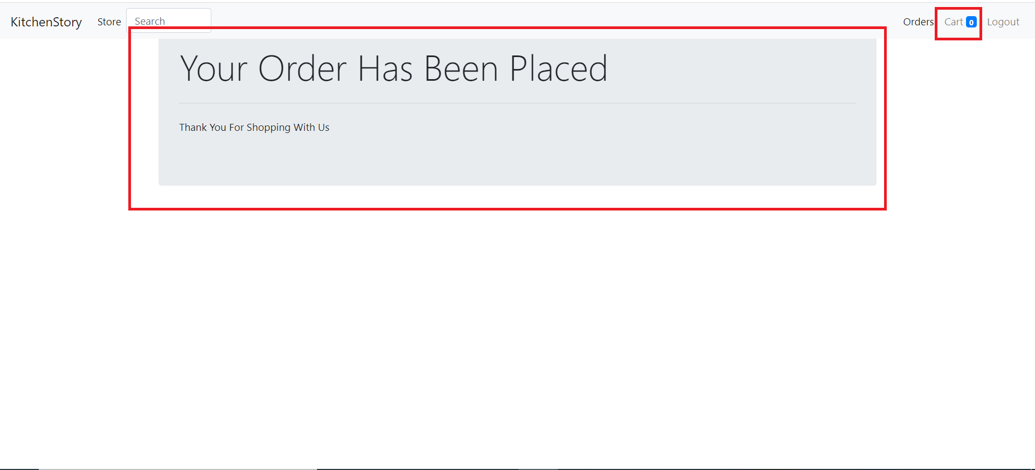

13. If nothing is selected in the cart then cart empty appears

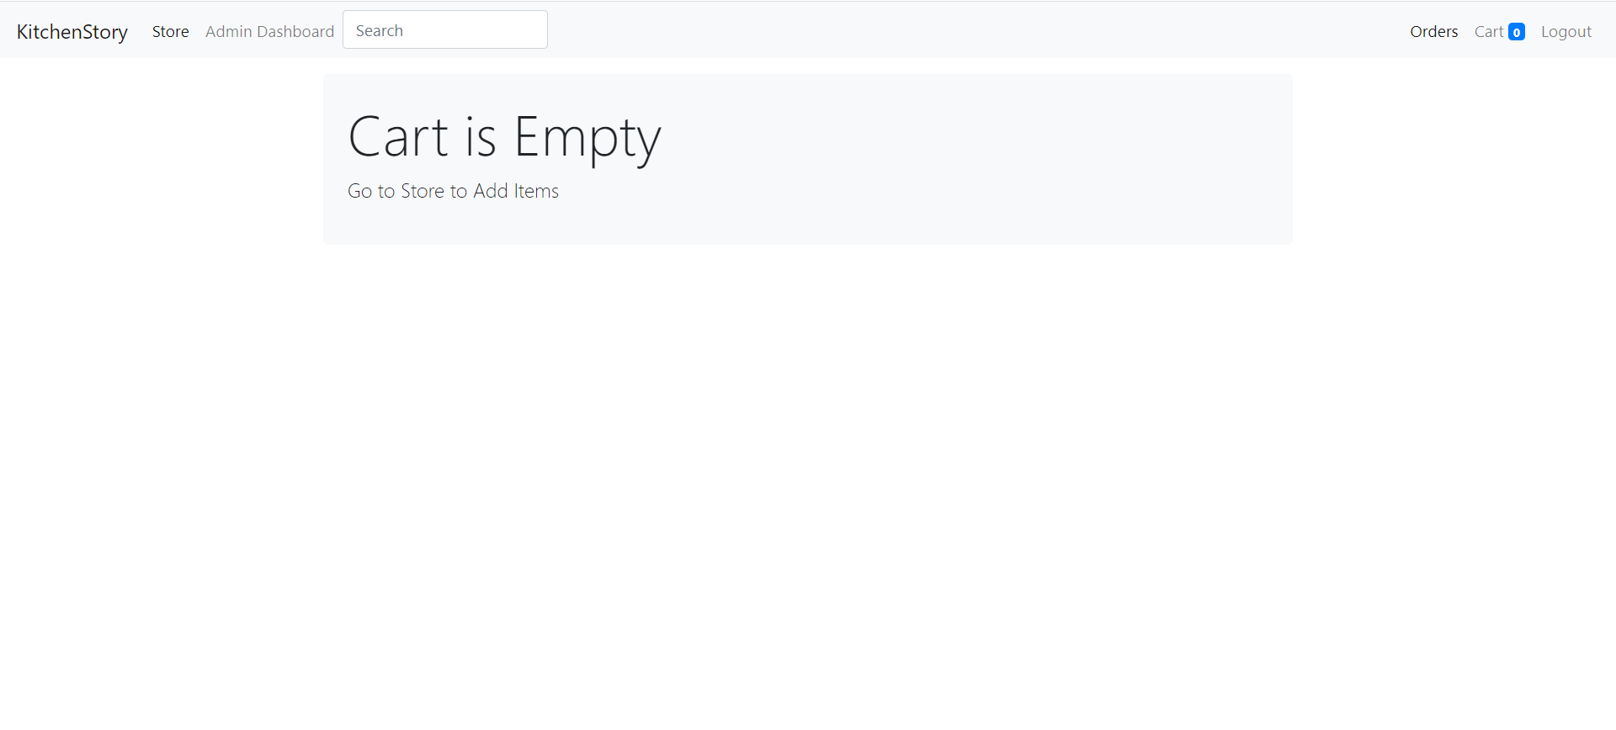

14. Admin Login

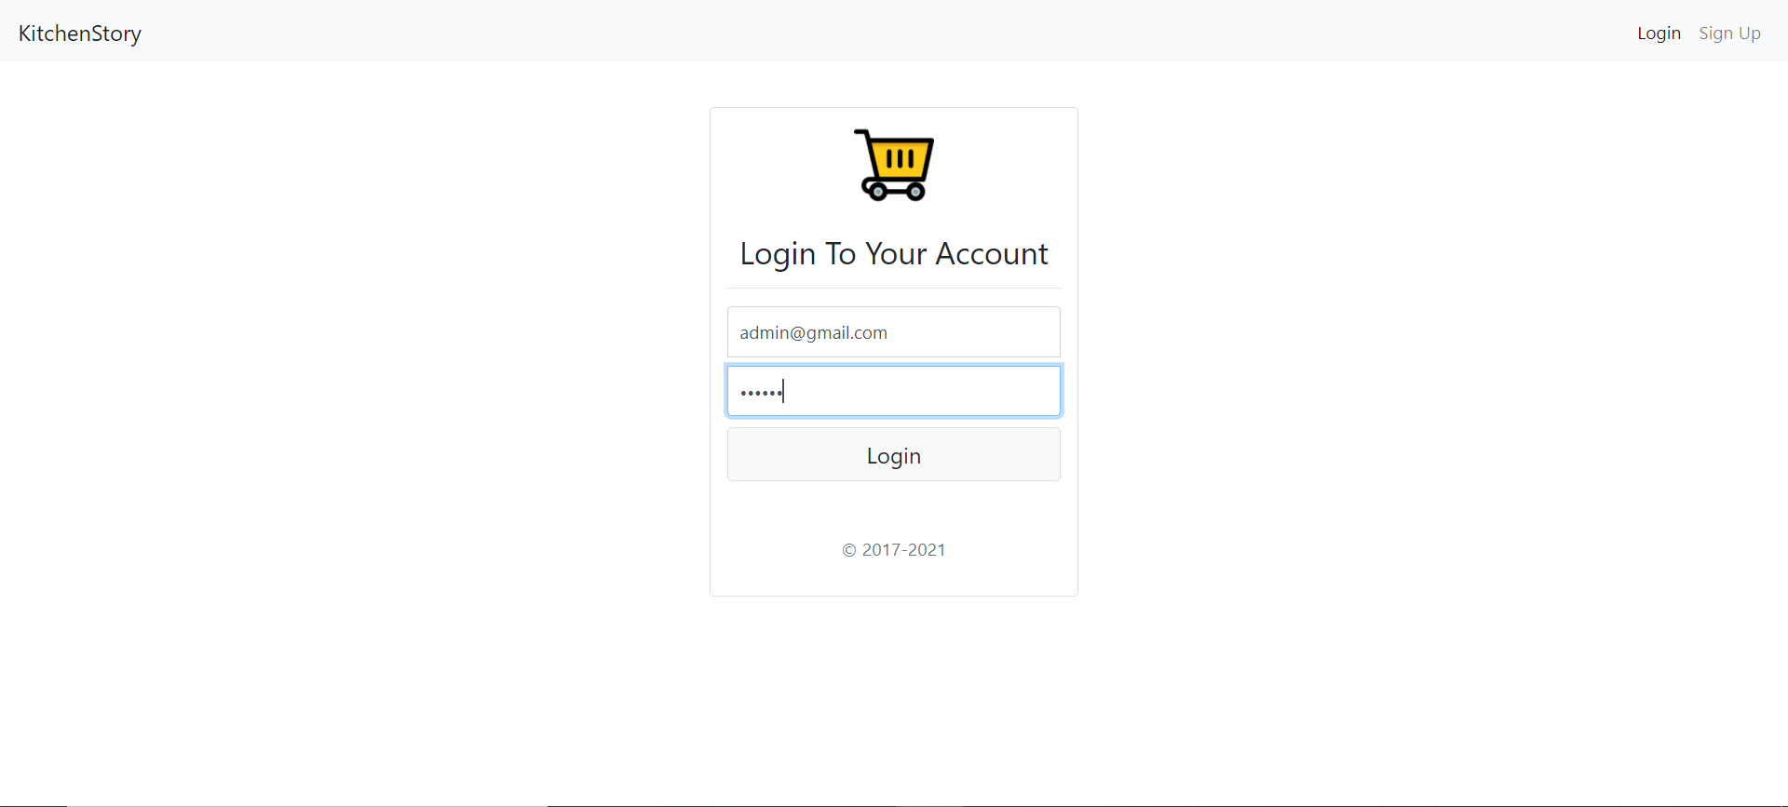

15. When Admin login new feature Admin Dashboard appears

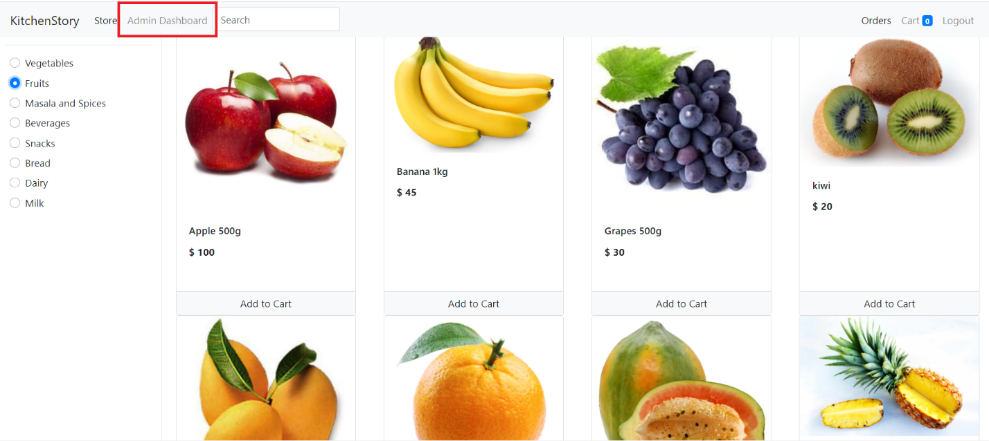

16. Inside the Admin Dashboard we have All Products, Add Products and Customers

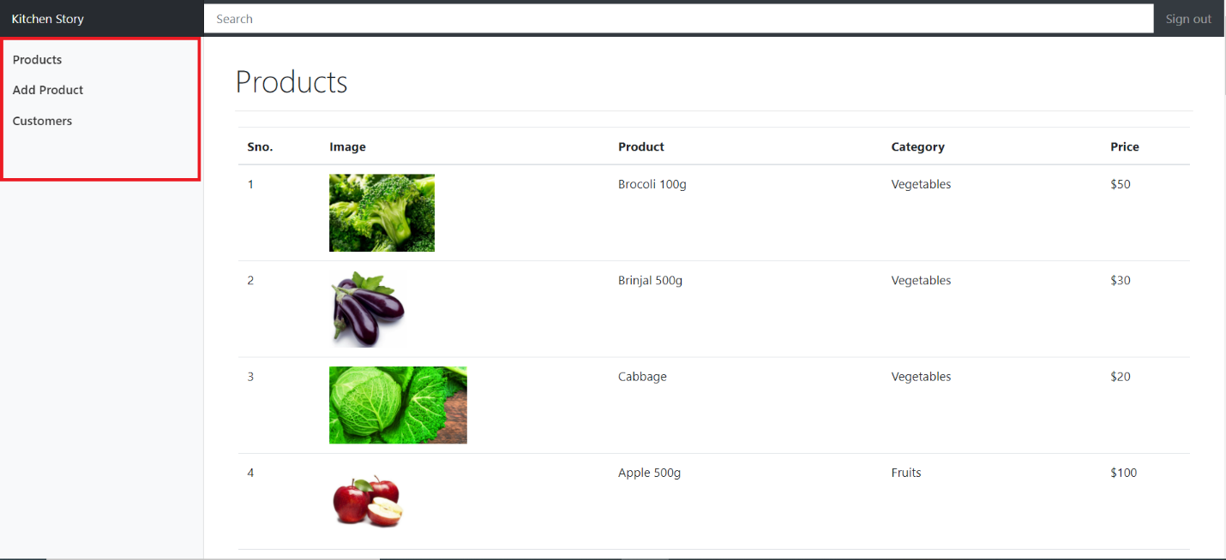

17. If we want to edit any product we have to select the product

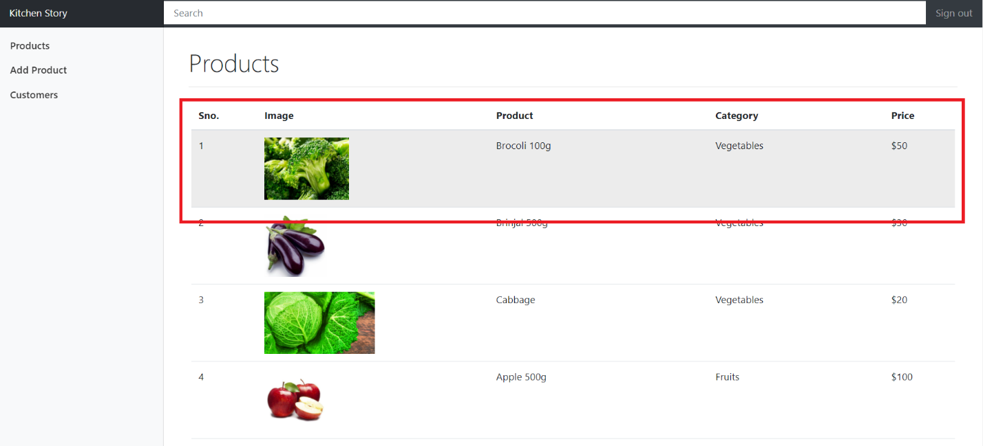

18. After selecting the product the Update Product and Delete Product form appears which has features to update and delete each product

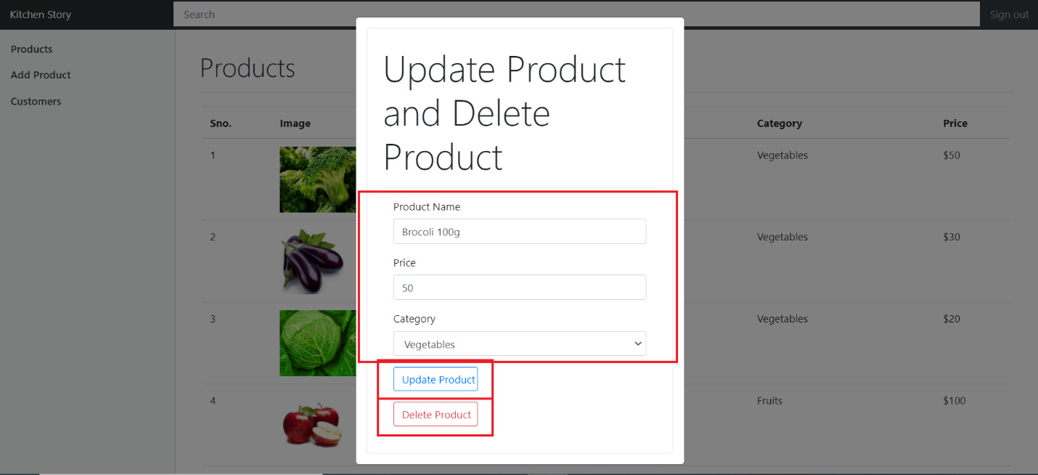

19. Add Product feature has to add new category and add new product

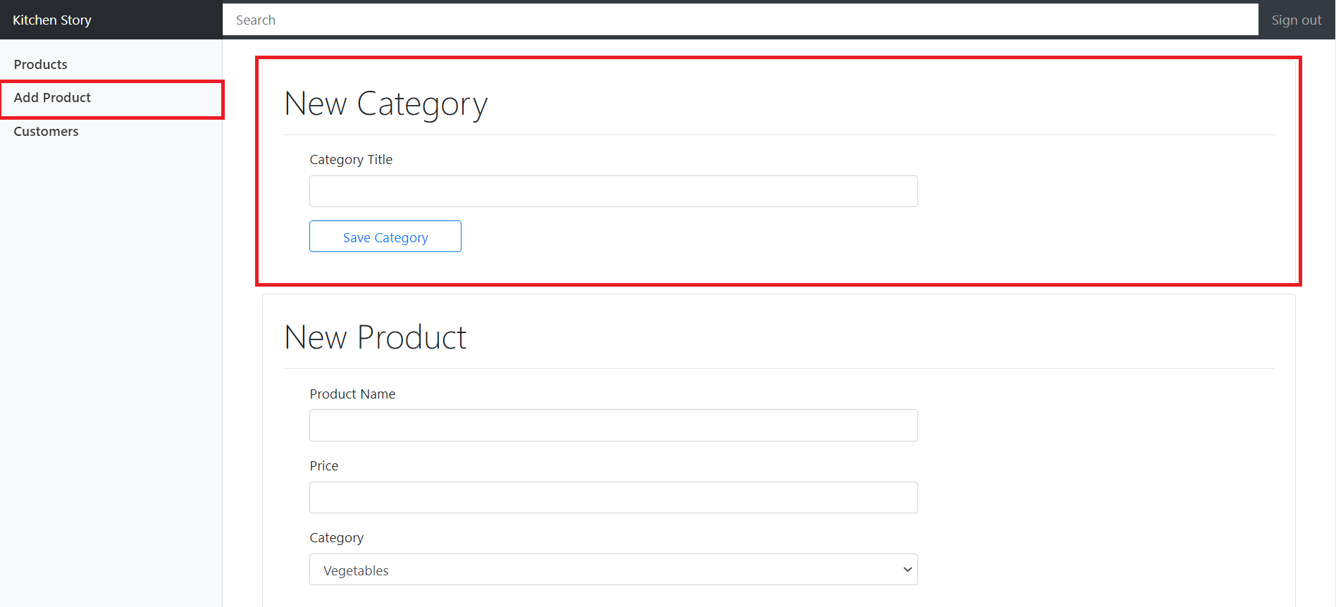

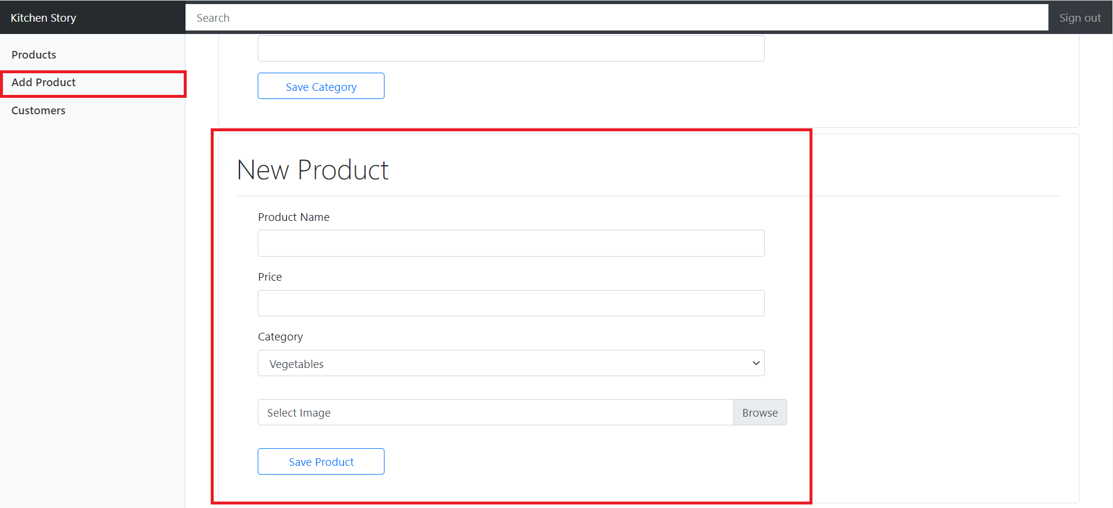

20. Customers Feature has the feature to edit the customer

